HOME AUTOMATION

FEASIBILITY REPORT

CLASS: EC5B

SUBMITTED BY,

Deepak J Puthukkaden

Rohit Sreekumar

Govindh B

Shine Ali

Giridhar A K

CONTENTS

1. The Idea
   1. Features Of The Project
   2. Block Diagram
   3. Hardware used
   4. Interface Protocols
2. Feasibility Survey
   1. Availability of Components
   2. Proposed Bill Of Materials
3. Bibliography/References
4. Scope For Further Improvement

1.THE IDEA

The proposed idea for our Mini Project for the academic year 2014-15 is home automation based on the Raspberry Pi. Automation is a broad concept of engineering and home automation is but a small subsidiary of this vast idea. Recently, the idea of the ***Internet Of Things*** has gathered momentum and many interesting applications have surfaced making the world a better place. We intend to implement a small scale automation project using the Raspberry Pi. The Raspberry Pi is a powerful Single Board Computer which is based on the Broadcom ARM11 Processor running at a speed of 700Mhz.

Due to the hardware limitations of the Raspberry Pi, we are forced to interface an additional microcontroller to control the various sensors involved in the automation.

* 1. Features of the project

The proposed idea will encompass almost all the basic aspects of a residential area.We intend to implement the following features in our project

* Adaptive Internal Lighting
* Temperature Controlled Air Conditioning
* Automatic External Lighting
* Automatic Water Supply system
* Keypad Enabled Door Lock system
* Interactive Music Player
* Data Logging and analysis

Adaptive Lighting System

The adaptive lighting system controls the amount of illumination in a room based on the external inputs about the amount of sunlight entering a room. The sensor involved is a ***light dependant resistor(LDR***) which gives out various analog voltage values depending on the amount of light falling on it.For demonstration purposes we intend to use an LED, the brightness of which is controlled using ***Pulse Width Modulation*** technique.

Temperature Controlled Air Conditioning

This feature of our project collects the real time data related to the room temperature and uses it to control the air conditioning or the fan speed in the room. For demonstration purposes we only log the temperature every 10-15 minutes and displays it in a serial monitor. The sensor used for the data collection is the LM35 temperature sensor manufactured by Texas Instruments Inc.

Automatic External Lighting

This feature of our project controls and external lighting system based on the time of the day. The time is obtained via an RTC chip (DS1307 by Maxim Integrated) interfaced with the Raspberry Pi.

Automatic Water Pumping System

Through this system we intend to control the water pump based on the water level inside the water tank. This prevents the overflowing and wastage of water which is a pristine and scarce resource. The water level is determined by two sensors and the output is used by the Raspberry Pi to drive a relay that switches the water pumping system.

Keypad Assisted Door Entry

This feature adds to the security of the smart home.A keypad is interfaced with the microcontroller which is then connected to a door lock system.The door lock gets unlocked when the correct pin is entered.

Integrated Home Entertainment System

This part of the project adds to the entertainment in the smart home. A music player is integrated into the Raspberry Pi which can play music using an installed software in the operating system.

Holistic Data Logging

This feature comprises of the data logging and event tracking feature of our project. Various information like the number of people inside the house at a particular point of time, the time in which maximum power consumption occurs, the room temperature etc. can be used to make analysis and take decisions for the optimization of power consumption.

* 1. Block Diagram

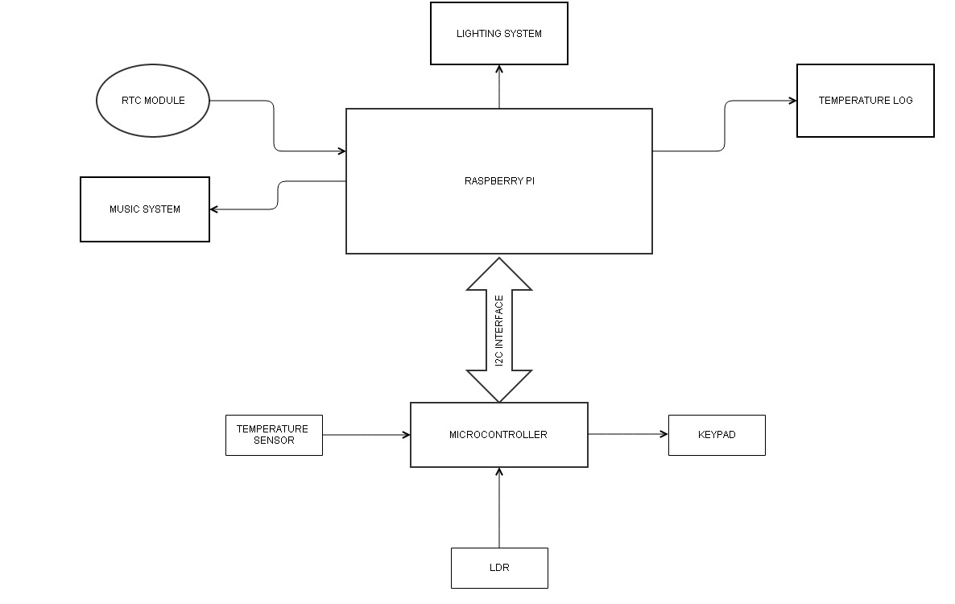

* 1. Hardware Used

Raspberry Pi

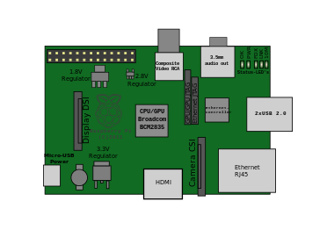

The **Raspberry Pi** is a credit-card-sized single-board computer developed in the UK by the Raspberry Pi Foundation with the intention of promoting the teaching of basic computer science in schools.

The Raspberry Pi has a ***Broadcom BCM2835*** system on a chip (SoC), which includes an ***ARM1176JZF-S700 MHz*** processor, VideoCore IV GPU,and was originally shipped with 256 megabytes of RAM, later upgraded to 512 MB. It does not include a built-in hard disk or solid-state drive, but it uses an SD card for booting and persistent storage.

The Foundation provides Debian and Arch Linux ARM distributions for download.Tools are available for Python as the main programming language, with support for BBC BASIC(via the RISC OS image or the Brandy Basic clone for Linux), C,Java and Perl.

LM35 Temperature Sensor

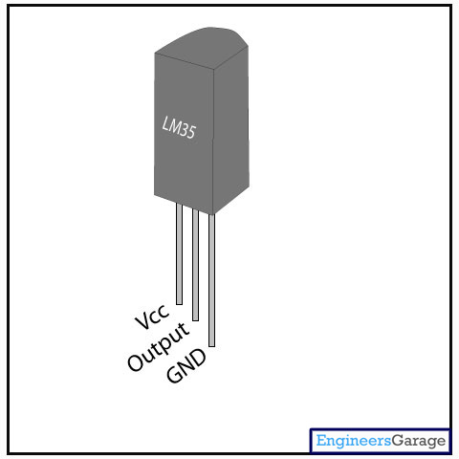

**LM35** is a precision IC temperature sensor with its output proportional to the temperature (in **o**C). The sensor circuitry is sealed and therefore it is not subjected to oxidation and other processes. With **LM35**, temperature can be measured more accurately than with a thermistor. It also possess low self heating and does not cause more than 0.1**o**C temperature rise in still air.

The operating temperature range is from -55°C to 150°C. The output voltage varies by 10mV in response to every **o**C rise/fall in ambient temperature, *i.e.,*its scale factor is 0.01V/**o**C.

DS1307 ( Real Time Clock Module):

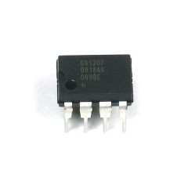

The DS1307 serial real-time clock (RTC) is a low-power, full binary-coded decimal (BCD) clock/calendar plus 56 bytes of NV SRAM. Address and data are transferred serially through an I²C, bidirectional bus. The clock/calendar provides seconds, minutes, hours, day, date, month, and year information. The end of the month date is automatically adjusted for months with fewer than 31 days, including corrections for leap year. The clock operates in either the 24-hour or 12-hour format with AM/PM indicator. The DS1307 has a built-in power-sense circuit that detects power failures and automatically switches to the backup supply. Timekeeping operation continues while the part operates from the backup supply.

* 1. Interface Protocols

I2C Interface Protocol:

**I²C** (**Inter-Integrated Circuit**,alternatelyspelled *I2C*,is a multimaster serial single-ended computer bus invented by the Philips semiconductor division,today NXP Semiconductors, and used for attaching low-speed peripherals to a motherboard,embedded system,cellphone, or other digital electronic devices. Several competitors, such as Siemens AG (later Infineon Technologies AG, now Intel mobile communications), NEC, Texas Instruments, STMicroelectronics (formerly SGS-Thomson), Motorola (later Freescale), and Intersil, have introduced compatible I²C products to the market since the mid-1990s.

2. Feasibility Survey

2.1 Availability of Components

We conducted an extensive survey about the availability of various components. We found that most of our sensors like the LM 35 and DS 1307 could be sampled from their manufacturers(Texas Instruments and Maxim Integrated). The Raspberry Pi is available for purchase online from their verified seller for a nominal price.Also, the microcontroller to be interfaced(Atmega 328P) could be sampled from their manufacturer(Atmel Inc.) . The other components like keypad and lcd display screen could be obtained locally.

2.2 Proposed Bill Of Materials

|  |  |  |
| --- | --- | --- |
| Sl No. | Material | Cost(INR) |
| 1 | Raspberry Pi | 3000 |
| 2 | Atmega 328 P | Sampled |
| 3 | LM35 | Sampled |
| 4 | LDR | 5 |
| 5 | DS1307 | Sampled |
| 6 | LCD Display | Salvaged from old components |
| 7 | Miscellaneous cost | 500 |
|  | Total Cost | 3505 |

3.Bibliography/References:

We are thankful to the following resources for enabling us to learn about the various aspects of this ambitious mini project:

1. [www.wikipedia.org](http://www.wikipedia.org/)
2. [www.ti.com](http://www.ti.com/)
3. [www.maximintegrated.com](http://www.maximintegrated.com/)
4. [www.adafruit.org](http://www.adafruit.org/)

4.Scope for Improvement

The scope for improvement is immense. The various data logs from the sensors can be shared over the internet and an algorithm can be implemented to take intelligent decisions regarding the power consumption etc. It could also be used to monitor the national averages etc. We could also incorporate wireless sensor networks for efficient power management.The Raspberry Pi can be configured to act as a radio transmitter.This acts as an emergency radio service. The keypad can be replaced by a voice recognition system.Also we could integrate voice control to almost all the features. The various sensors can be connected to the central microcontroller unit via Zigbee Modules.